




Project Report

On

“Smart Stick For Blind Person”

Submitted for partial fulfilment of

Diploma in
Computer Engineering

B
y

22
CM010 Naman Sunil Bharsakale

22
CM016 Sarvesh Sham Chaudhari

CM019 Yash
22
Sandip Chaukhande

22
CM030 Jay Ajay Ganorkar

23
CM206 Mohammad Shahzad Mohammad Zameer

Under the guidance of

Mrs. C.

R. Chaudhari

Department of Computer Engineering

GOVERNMENT

POLYTECHNIC
,

AMRAVATI

.

(
An Autonomous Institute of Govt.

of Maharashtra)

2024
-
25

Project Report
On
“Smart Stick For Blind Person”

Submitted for partial fulfillment of the
Diploma course in
Computer Engineering
By
22CM010- Naman Sunil Bharsakale
22CM016- Sarvesh Sham Chaudhari
22CM019- Yash Sandip Chaukhande
22CM030- Jay Ajay Ganorkar
23CM206- Md. Shahzad Md. Zameer

Under the guidance of

Mrs. C. R. Chaudhari



Department of Computer Engineering
GOVERNMENT POLYTECHNIC AMRAVATI
(An Autonomous Institute of Govt. of Maharashtra)
2024-25


Department of
Computer Engineering

GOVERNMENT POLYTECHNIC
,

AMRAVATI

(
An Autonomous Institute of Govt.

of Maharashtra)

CERTIFICATE

This is to certify that the Project titled

“
Smart
Stick For Blind Person
”

By

22
CM010 Naman Sunil Bharsakale

22
CM016 Sarvesh Sham Chaudhari

22
CM019 Yash Sandip Chaukhande

22
CM030 Jay Ajay Ganorkar

23
CM206 Md. Shahzad Md. Zameer

In the partial fulfillment of the Diploma Course in

Computer Engineering

During the academic year 2024
-
2025.

Dr.P.P.Karde

Head,

Dept. of Computer Engineeing

(
Name & Sign of

External Examiner

Dr.V.R.Mankar

Principal

Government Polytechnic, Amravati

Mrs. C. R. Chaudhari

Project Guide

Dept .Computer Engineering

GOVERNMENT POLYTECHNIC
AMRAVATI
(An Autonomous Institute of Govt. of Maharashtra)

_{INSTITUTE VISION}
- To be a vibrant technical institute of global reputes contributing towards the needs of industries & society.

INSTITUTE MISSION
- To develop competent diploma engineers suitable for contemporary industrial environment.
- To inculcate socially accepted ethics & values among budding engineers.
- To nurture innovations and entrepreneurship.
- To produce engineers with psychomotor & cognitive skills committed to lifelong learning.

GOVERNMENT POLYTECHNIC AMRAVATI
(An Autonomous Institute of Govt. of Maharashtra)

DEPARTMENT VISION
- To ensure an excellent education environment with the technical capability in the field of IT engineering to serve the vibrant Industry & Society.
DEPARTMENT MISSION
- Facilitate Students to learn the basics of IT Engineering entailing the technical gain.
- Train Students with technical skills with rational capacity to meet the requirements of industry with technological aspect.
- Motivate the students for an advanced knowledge in IT engineering and other value-added programs for their holistic development.
- Imparting ethical values, leadership and social values in Students which transform them into good human being.
- Provide an academic environment and consultancy services to the industry and society in the area of IT & Computer engineering.

COURSE OUTCOMES (COs)
At the end of this course student will able to
- Implement the project planning activities planned in previous course.
- Finalize the problem for project.
- Collect relevant information and data for identified project topic.
- Analyze and compile the collected data.
- Generate a project report based on the experiences and project execution carried out.
- Present the project report using ppt.

ACKNOWLEDGEMENT

It gives us immense pleasure in submitting the project report on topic “LAB AUTOMATION SYSTEM”. To our guide Ms. R. J. Rangari who was a constant source of guidance and inspiration for developing for preparation of project.

We are also thankful to all staff members of Information Technology department, who have indirectly guided and helped us in preparation of this project. We are extremely thankful to Dr. V. R. Mankar, Principal and Dr. P. P. Karde Head of Department of Information Technology, for providing all the required sources for the successful completion of our project.

At last we are thankful to my friends whose encouragement and constant inspiration helped us so for the preparation of the project.

Thanking you,

Projectees-
Id code | Name of Student
20IF043 | Diksha P. Nichat
20IF026 | Naresh R.Jodha
20IF059 | Samruddhi A. Sarode
20IF028 | Lakhan A.Kariya
20IF004 | Neha S. Balsaraf

GOVERNMENT POLYTECHNIC,
AMRAVATI
(An Autonomous Institute of Govt. of Maharashtra) (2022-2023)

Declaration

We undersigned hereby declare that the microproject report entitles

“Lab Automation System”

Contents is the outcome of my own literature survey. We further declare that contents of this report are property cited as well knowledged. This present report is not submitted to any other examination of this or any other Institute.

Place: Amravati Signature

Date: / / Government Polytechnic, Amravati

Sr.No | Name & of Student | sign
1. | 20IF043-Diksha P. Nichat
2. | 20IF026-Naresh R.Jodha
3. | 20IF059-Samruddhi A. Sarode
4. | 20IF028-Lakhan A.Kariya
5. | 20IF004-Neha S. Balsaraf

INDEX
CONTENTS |  |  | Page No.
ABSTRACT
Chapter 1 - Introduction |  |  | 1
Chapter 2 - Literature Survey. |  |  | 4
Chapter 3 - Structure of the Project | 3.1 | Problem Definition | 8
 | 3.2 | Proposed system | 9
 | 3.3 | Tools And Platform | 10
 | 3.4 | Project types | 14
 | 3.5 | Hardware requirement for project and end user | 15
 | 3.6 | Software requirement for project and end user | 17
Chapter 4 – Methodology and  Module | 4.1 | Methodology | 19
 | 4.2 | Module Description | 21
Chapter 5 - Design (Data Flow, Structure Flow and Database Design, Block Diagram) |  |  | 23
Chapter 6 - Advantages |  |  | 27
Chapter 7- Application, Limitation, and scope of Project |  |  | 29
Result / Snapshot |  |  | 32
CONCLUSION |  |  | 37
FUTURE SCOPE |  |  | 38
REFERENCES |  |  | 39

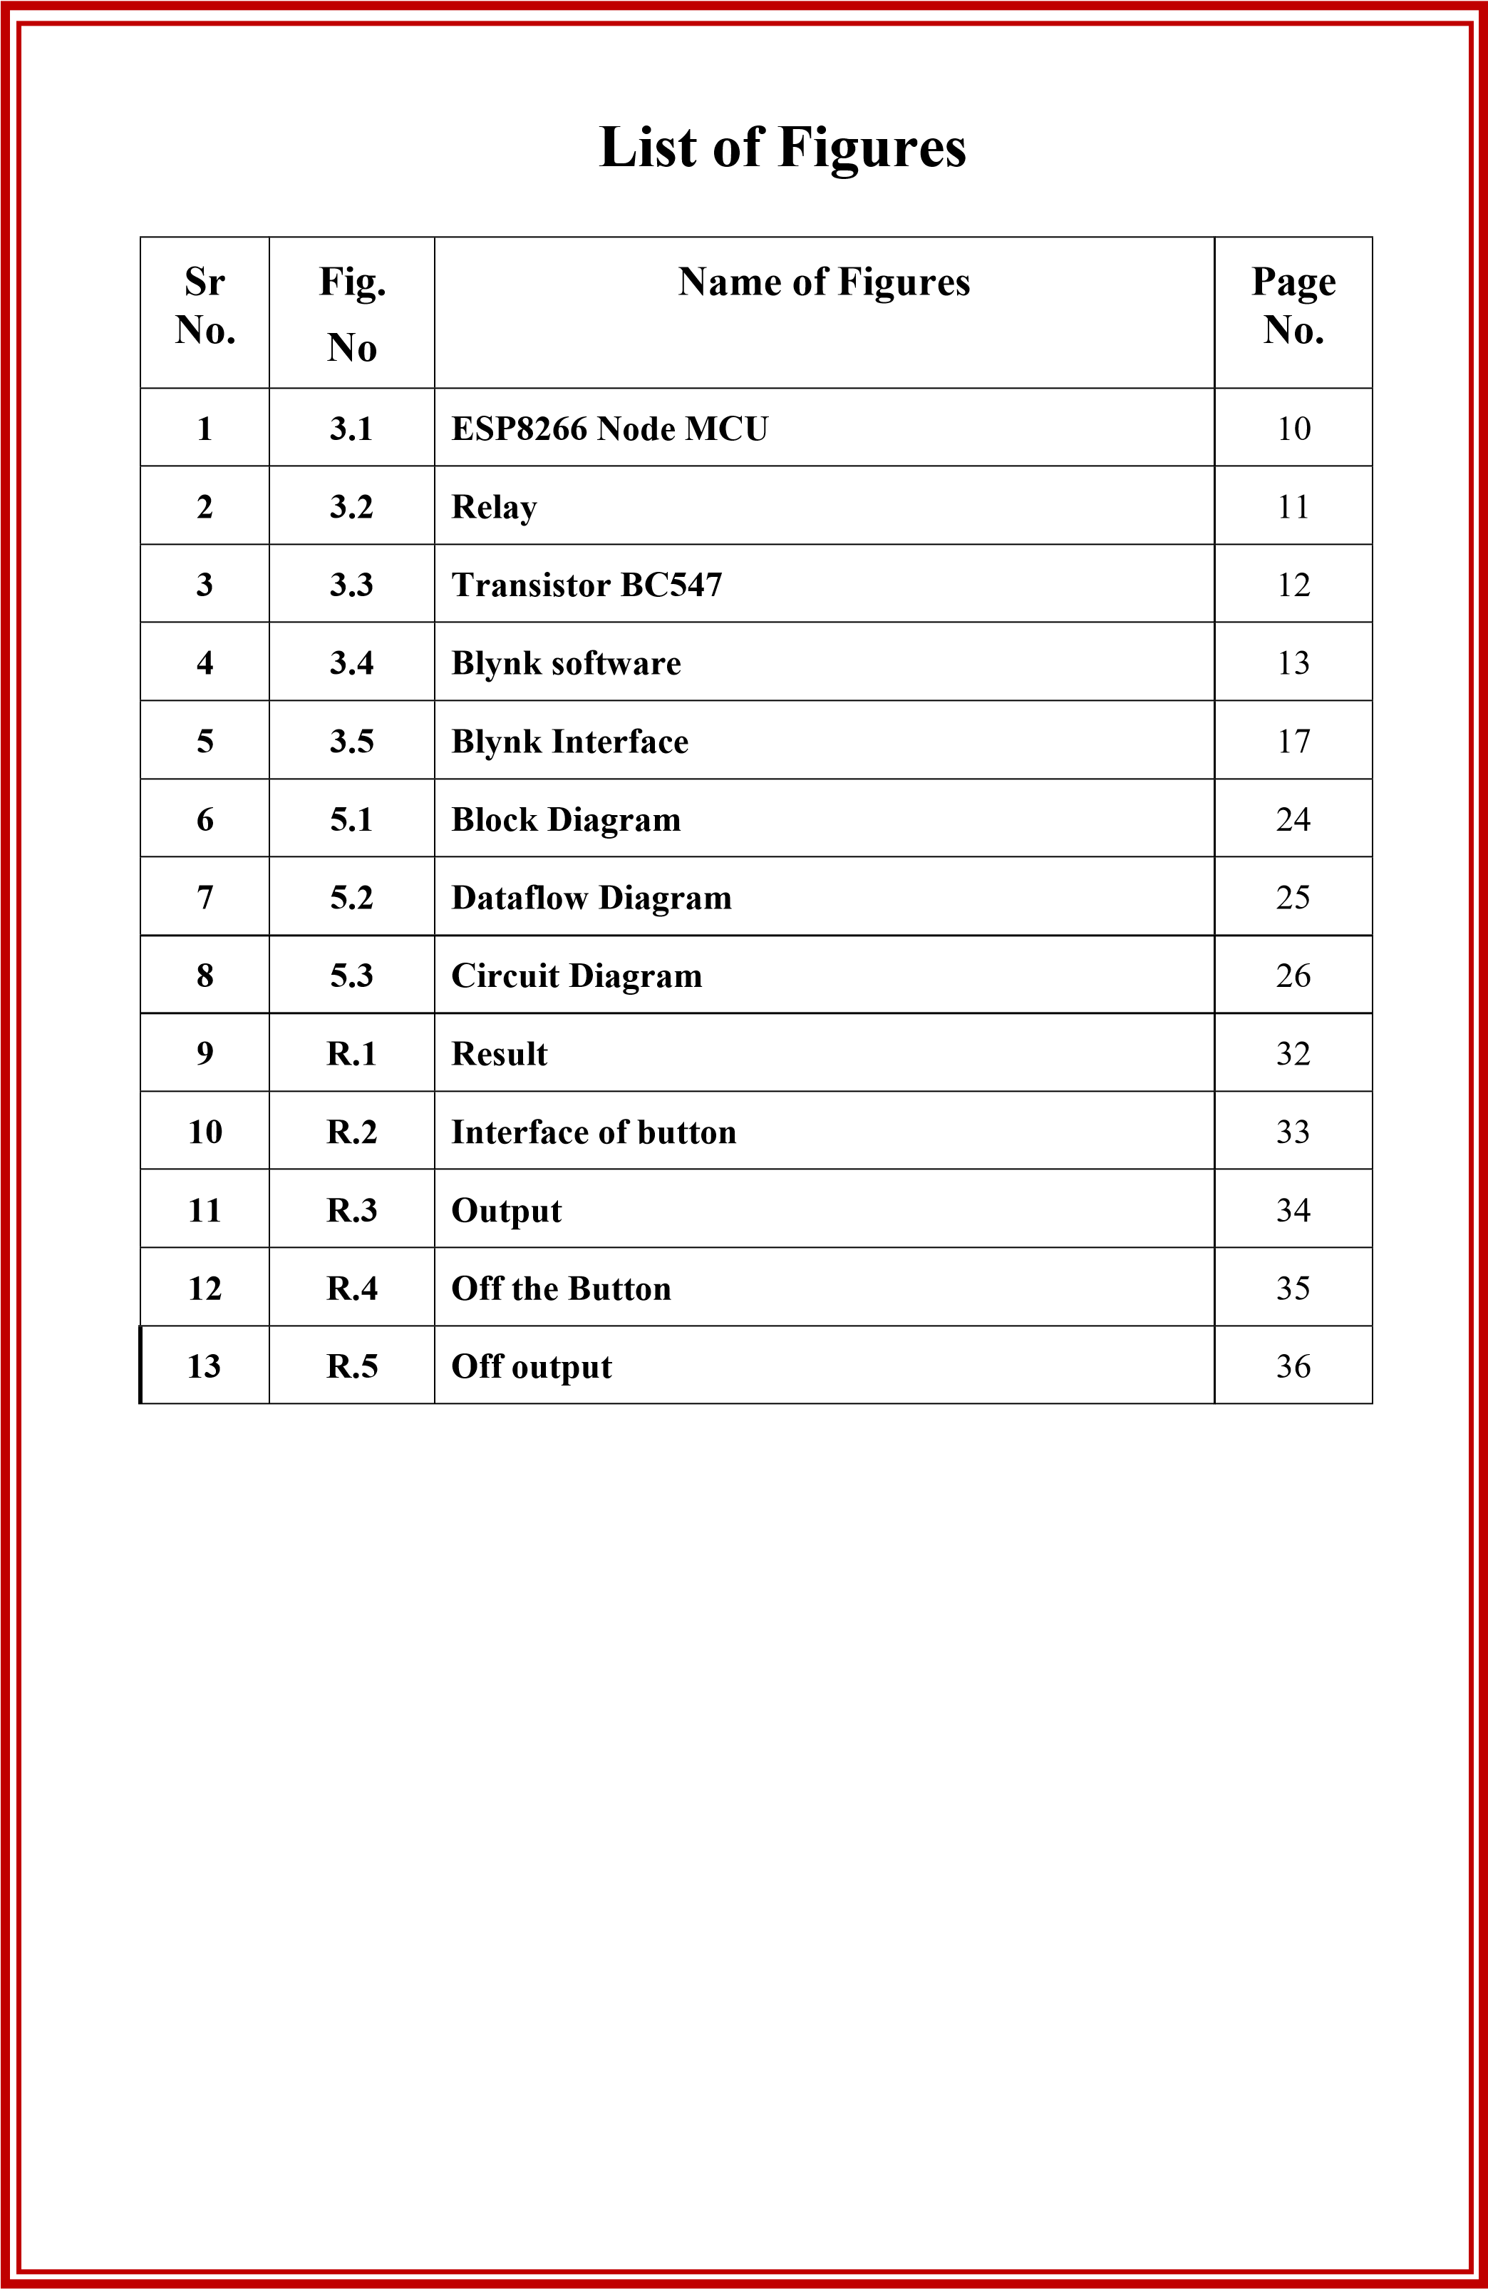

ABSTRACT

The lab automation project based on ESP8266 is a cutting-edge solution that aims to streamline and optimize laboratory processes by leveraging the power of the Internet of Things (IoT) and the popular ESP8266 microcontroller. The project involves designing and implementing a smart lab automation system that is capable of monitoring and controlling various lab equipment and processes remotely through a web-based
Interface.
The system is built using the ESP8266 microcontroller, which provides Wi-Fi connectivity and can communicate with other devices over the internet. The system includes sensors and actuators that are integrated with the ESP8266 to gather data and perform actions, respectively. The collected data is processed and analyzed in real-time using custom software, and the results are displayed on a user-friendly web interface accessible from any device with internet connectivity.
The lab automation system offers a wide range of functionalities, including temperature and humidity monitoring, pH sensing, automated liquid dispensing, and remote control of lab equipment such as centrifuges, incubators and shakers. The system also includes features for data logging, notifications, and alerts, allowing lab personnel to monitor experiments and processes remotely and receive real-time updates.
The implementation of the lab automation system based on ESP8266 offers several benefits, including increased efficiency and productivity in the lab, reduced human error. improved data accuracy, and the ability to remotely monitor and control lab processes from anywhere at any time. The system has the potential to revolutionize laboratory workflows and contribute to the advancement of scientific research and experimentation in various fields, including pharmaceuticals, biotechnology. chemistry, and life sciences.
The Lab Automation Project based on ESP8266 is a cutting-edge system designed to streamline and optimize laboratory processes using Internet of Things (IoT) technology, The project aims to automate various task in a laboratory setting, such as temperature monitoring, humidity control, and equipment control, to improve efficiency, accuracy, and safety
The core of the system is the ESP8266 microcontroller, which is integrated with sensors and actuators to collect real-time data from the lab environment and control equipment accordingly. The ESP8266 is connected to a Wi-Fi network, enabling remote monitoring and control of the lab processes from a web-based interface accessible through desktop or mobile devices.
The Lab Automation Project utilizes a modular and scalable architecture, allowing for easy customization and expansion based on specific lab requirements. The system is designed to be user-friendly, with an intuitive graphical user interface (GUI) that

provides real-time data visualization, alerts, and notifications, making it easy for lab personnel to monitor and control lab processes effectively
The project also includes robust security features to protect sensitive data and ensure the integrity of the laboratory processes Data encryption, user authentication, and role- based access control (RBAC) are implemented to prevent unauthorized access and maintain data confidentiality.
The Lab Automation Project based on ESP8266 offers numerous benefits, including Increased efficiency, reduced human error. improved safety, and enhanced data accuracy. It has the potential to revolutionize laboratory processes, making them more automated, streamlined, and reliable. The project serves as a proof of concept for the integration of lot technology into laboratory automation and can be extended to other domains that require real- time monitoring and control of processes.

CHAPTER -01 INTRODUCTION

INTRODUCTION
A Lab automation has become a popular concept in recent years, allowing
individuals to remotely control various electronic devices within their homes. One of the most commonly used technologies in lab automation projects is the ESP8266, a low-cost Wi-Fi module that can be programmed to control various appliances. In this project, we will be using the ESP8266 module to create a lab automation system that can control two different appliances. Through this project, we hope to showcase the versatility and practicality of the ESP8266 module and inspire individuals to explore further possibilities of lab automation using this technology.
In today's fast-paced world, Lab automation has become an essential part of our lives. With the advancement of technology, it is now possible to control various devices and appliances in our lab’s remotely. One such technology is the ESP8266, a low-cost Wi-Fi chip that has revolutionized the field of Lab automation. In this project, we will be using the ESP8266 module to create a Lab automation system that will allow us to control two appliances remotely.
In the realm of scientific research and analysis, lab automation systems have emerged as a transformative technology, revolutionizing laboratory workflows and processes. By combining robotics, artificial intelligence, and sophisticated software, these systems automate routine tasks, improve efficiency, enhance accuracy, and enable scientists to focus on complex analysis and decision-making. This paper provides an introduction to lab automation systems, highlighting their significance, components, and diverse applications across scientific disciplines.
The traditional laboratory environment presents numerous challenges, including manual handling of samples, time-consuming processes, human errors, limited throughput, and rising labor costs. These challenges not only hinder productivity but also introduce the risk of compromised data integrity and reproducibility. Lab automation systems address these issues by introducing advanced technologies that streamline workflows and elevate the capabilities of laboratories.
At the heart of lab automation systems are robotic systems equipped with sophisticated mechanisms, sensors, and computer vision capabilities. These robots can perform a range of tasks, such as sample preparation, liquid handling, plate handling, and sample transportation, with precision and repeatability. They reduce the reliance on manual labor, enabling scientists to handle higher volumes of samples and execute experiments more efficiently.
Lab automation systems integrate various instruments, such as analyzers, centrifuges, spectrophotometers, and microscopes, creating a cohesive laboratory ecosystem. These instruments are interconnected and controlled through automation software and interfaces, allowing for seamless workflow management and data exchange. The software plays a vital role, providing intuitive user interfaces, workflow design tools, instrument control, and data management capabilities. It enables scientists to design and execute complex experiments, monitor progress, and analyze results effectively.
The applications of lab automation systems span diverse scientific fields. In drug discovery and genomics research, these systems facilitate high-throughput screening, enabling the rapid testing of large compound libraries and identification of potential drug candidates. In clinical diagnostics, lab automation systems streamline diagnostic workflows, enhance accuracy, and accelerate testing processes, resulting in improved patient care. In genomics, these systems automate next-generation sequencing workflows, enabling researchers to generate large-scale genomic datasets efficiently.
Looking ahead, lab automation systems hold tremendous potential for further advancements. The integration of artificial intelligence and machine learning algorithms can optimize workflows, predict outcomes, and enable intelligent decision-making within these systems. Standardization and interoperability will also be critical, ensuring seamless integration between different systems and instruments, enabling data sharing, and fostering collaboration.
This project is designed to be simple and easy to implement, making it an ideal starting point for anyone interested in Lab automation. With the help of this project, you can control your appliances from anywhere in the world, giving you greater convenience and flexibility in managing your Lab.

CHAPTER-02
LITERATURE SERVEY

LITERATURE SERVEY

Lab automation has become a critical aspect of modern scientific research and experimentation. The use of Internet of Things (IoT) devices, such as the ESP8266, has enabled laboratories to automate various tasks and processes, leading to improved efficiency, accuracy, and reproducibility of experiments. Here is a literature survey of some key studies and projects that have utilized the ESP8266 for lab automation.
- "Wireless Monitoring System for Laboratory Equipment using ESP8266" by Varpe et al. (2018) This study proposed a wireless monitoring system for laboratory equipment using the ESP8266 module. The system was designed to monitor parameters such as temperature, humidity, and light intensity in a laboratory setting, and the collected data was transmitted wirelessly to a cloud-based server for real-time monitoring and analysis. The authors demonstrated the feasibility of using the ESP8266 for wireless monitoring of laboratory equipment, which could enhance the efficiency and reliability of laboratory experiments.
- "IoT Based Laboratory Automation for Smart Laboratories" by Sengupta et al. (2019) This research article proposed an lo T-based laboratory automation system using the ESP8266 for smart laboratories. The system Incorporated various sensors and actuators to automate tasks such as temperature and web-based user interface for remote monitoring and control of laboratory equipment using the ESP8266, which could facilitate remote operation and humidity control, pH monitoring, and sample mixing. The authors implemented a management of experiments in a laboratory environment.
- "Automated Bioreactor Control System using ESP8266 for Microbial Cultivation" by Vasudevan et al. (2020) This study presented an automated bioreactor control system using the ESP8266 for microbial cultivation. The system utilized the ESP8266 module to monitor and control parameters such as temperature, pH, and dissolved oxygen in a bioreactor for microbial fermentation. The authors developed a mobile application for real-time monitoring and control of the bioreactor, providing a user-friendly interface for remote management of microbial cultivation experiments.
- "Lab Monitoring System with Wireless Sensor Network using ESP8266 for Precision Agriculture" by Khan et al. (2021) This research article proposed a lab monitoring system with a wireless sensor network using the ESP8266 for precision agriculture applications. The system incorporated multiple wireless sensor nodes based on the ESP8266 module to monitor parameters such as temperature, humidity, soil moisture, and light intensity in a lab environment. The collected data was transmitted wirelessly to a central server for analysis and decision-making. The authors demonstrated the potential of using the ESP8266 for precision agriculture, where lab automation can play a crucial role in optimizing crop production.
- "ESP8266-based Lab Automation for Monitoring and Control of Chemical Reactions" by Vasanth et al. (2021) This study presented an ESP8266-based lab automation system for monitoring and control of chemical reactions: The system utilized the ESP8266 module to monitor and control parameters such as temperature, pressure, and gas flow in a chemical reaction setup. The authors developed a web-based user interface for remote monitoring and control of the chemical reactions, which could enhance the safety, accuracy, and reproducibility of chemical experiments in a laboratory setting.

CHAPTER -03
STRUCTURE OF THE PORJECT

3.1 PROBLEM DEFINATION

Lab automation refers to the use of technology and automation systems to streamline and optimize laboratory processes, reduce human error, and improve efficiency in various scientific, research, and testing environments. The ESP8266 is a popular and affordable Wi- Fi-enabled microcontroller that can be used as a building block for lab automation projects.
The problem that this lab automation project aims to address is the manual and time- consuming nature of certain laboratory tasks that can be prone to errors, inefficient, and laborintensive. This can include tasks such as temperature and humidity monitoring, data logging, equipment control, and remote access to lab instruments or devices.
The current manual methods of data collection, analysis, and control in the lab can be tedious, error-prone, and limit the ability to remotely monitor and manage experiments or processes. Additionally, labs may have multiple instruments or devices that are not interconnected, leading to disjointed data collection and lack of real-time insights.
The lab automation project based on ESP8266 aims to leverage the capabilities of this microcontroller to develop a system that can automate and streamline various lab processes.
This can include:
- Remote Monitoring and Control: Developing a system that allows remote monitoring and control of lab instruments or devices using the ESP8266's Wi-Fi capabilities. This can enable scientists or researchers to monitor experiments, collect data, and control instruments remotely from a web browser or a mobile app, reducing the need for physical presence in the lab.
- Data Logging and Analysis: Implementing a data logging and analysis system using the ESP8266 that can collect and store data from various lab instruments or sensors in a centralized database. This can enable real- time data analysis, visualization, and reporting, allowing researchers to gain insights and make data-driven decisions.
- Automated Control of Lab Equipment: Developing a system that can automatically control lab equipment, such as pumps, heaters, or incubators, based on predefined conditions or schedules. This can reduce human error, optimize processes, and improve efficiency in the lab.
- Integration of Lab Instruments: Integrating different lab instruments or devices, such as spectrometers, chromatographs, or balances, into a unified system using the ESP8266. This can enable seamless communication, data sharing, and coordination among different instruments, leading to a more integrated and efficient lab workflow.
- User-friendly Interface: Creating a user- friendly interface, such as a web-based dashboard or mobile app, that allows scientists or researchers to easily configure, monitor, and control the lab automation system based on ESP8266. This can enhance usability, accessibility, and adoption of the system in the lab.

3.2 PROPOSED SYSTEM

In the realm of scientific research and analysis, the efficient management of laboratory workflows and data is crucial for achieving accurate results and maximizing productivity. To address these challenges, we propose the implementation of a software-based lab automation system. This system aims to optimize laboratory processes, automate routine tasks, and streamline data management through intuitive interfaces, workflow design tools, and data analysis capabilities. This proposal outlines the key features, benefits, and potential applications of the software lab automation system.
The primary objective of the proposed software lab automation system is to enhance efficiency and productivity in laboratory settings. The system aims to automate routine tasks, reduce human errors, and improve data integrity and reproducibility. Additionally, it seeks to streamline workflow management, facilitate real-time data acquisition and analysis, and promote collaboration among researchers and scientists.
The software lab automation system encompasses several key features that enable efficient laboratory operations and data management:
Workflow Design and Execution:
The system provides a user-friendly interface for designing and customizing laboratory workflows. Researchers can easily create, modify, and execute complex experimental protocols through drag-and-drop functionality and pre-configured templates. The system allows the inclusion of various steps, such as sample handling, reagent addition, instrument control, and data acquisition.
Instrument Integration and Control:
The software seamlessly integrates with a wide range of laboratory instruments, including analyzers, liquid handlers, and spectrophotometers. It provides standardized interfaces and protocols for instrument control, enabling researchers to program instrument settings, initiate experiments, and monitor real-time data acquisition. This integration ensures compatibility and enhances instrument utilization.
Data Acquisition and Management:
The software lab automation system enables efficient data acquisition and management. It captures and stores experimental data in a centralized database, ensuring secure storage and easy accessibility. Researchers can track and analyze data in real-time, generate reports, and export data for further analysis. The system also provides data visualization tools for easy interpretation and decision-making.

3.3 TOOLS AND PLATFORMS

ESP8266 NODE MCU
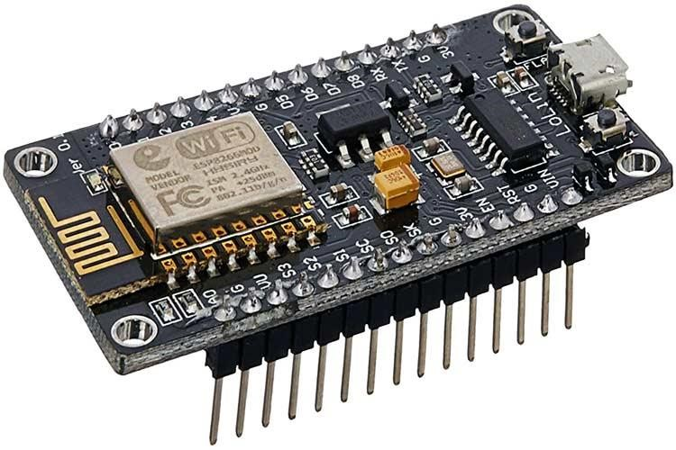

Fig.3.1 ESP8266 NODE MCU

The ESP8266 is a low-cost Wi-Fi module that was first introduced in 2014. It is a highly popular device among developers due to its low cost and versatility. The ESP8266 development board is a circuit board that incorporates an ESP8266 chip and makes it easy to program and use.
FEATURES :-
- Wi-Fi connectivity: The ESP8266 development board allows for easy Wi-Fi connectivity, which makes it ideal for loT projects and other connected devices.

- Small form factor. The board is small and compact. making it easy to integrate into various projects.

- GPIO pins: The board has a set of GPIO (General Purpose Input/Output) pins that allow for easy interfacing with other sensors and devices .

- Programming The board can be programmed using the Arduino IDE. which is a popular programming language among developers.

- Low power consumption: The board has low power consumption, which makes it ideal for battery-powered devices.

- Cost-effective: The ESP8266 development board is relatively inexpensive compared to other microcontrollers and development boards.

RELAY

Fig.3.2 Relay

The relay is an electrical component that is used to control the flow of current in an electrical circuit. It works by using an electromagnet to mechanically switch a set of contacts that control the flow of current in the circuit Relays are used in a wide variety of applications from simple on/off switches to complex control systems.
The basic structure of a relay consists of a coil of wire and a set of contacts. When a voltage is applied to the coll, it creates a magnetic field that causes the contacts to move and complete or break a circuit Relays are available in a variety of sizes and configurations, and can be designed to switch both AC and DC voltages.
One of the main advantages of relays is their ability to switch high voltage and high current loads with very low power consumption. This makes them ideal for use in applications such as motor control lighting control and power distribution systems.
Relays can also be used to provide isolation between circuits, which is important in applications where the control circuit and the load circuit need to be isolated from each other. This can help to prevent electrical noise and interference from affecting the operation of the circuit.
Relays are commonly used in automotive applications where they are used to control everything from the headlights to the air conditioning system. They are also used in industrial applications, such as in manufacturing processes, where they can be used to control the operation of machines and equipment.
Relays are an important component in many electrical systems, and their versatility and reliability make them a popular choice for a wide range of applications

TRANSISTOR BC547
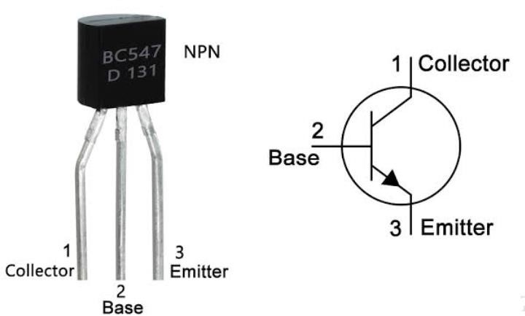

Fig.3.3 TRANSISTOR BC547

The BC547 is a widely used general-purpose NPN bipolar junction transistor (BJT) that is commonly employed in amplification and switching applications. It is a low- power device with a maximum current rating of 100 mA and a maximum voltage rating of 45V. SPECIFICATIONS:-
- Collector current (Ic): up to 100 mA
- Collector-emitter voltage (Vce): up to 45V Power dissipation (Pd) up to 500 mW
- DC current gain (hfe): typically between 110 and 800
- Transition frequency (fT): typically 300 MHz
The BC547 has three terminals: the emitter, the base, and the collector. The base is the control terminal and is used to control the flow of current between the emitter and the collector. The emitter is connected to the negative terminal of the power supply, while the collector is connected to the positive terminal.
The BC547 is available in various packages, such as TO- 92, SOT-23, and SOT-223, making it suitable for use in a wide range of applications. It is widely used in audio amplifiers, voltage regulators, and switching circuits, among other applications.

BLYNK SOFTWARE



Fig.3.4 BLYNK SOFTWARE

Blynk is a popular mobile app development platform that allows developers to create custom
Internet of Things toT) applications. The platform provides an easy- to-use interface for developers to create applications for controlling and monitoring devices remotely. Blynk allows developers to create mobile apps for Android and iOS devices, as well as web-based applications for desktop and laptop computers
The Blynk platform provides a library of pre-built widgets that developers can use to quickly create applications. These widgets include buttons, sliders, gauges, graphs, and more. Developers can also create custom widgets using HTML, CSS, and JavaScript.
Blynk uses a cloud-based infrastructure that allows developers to easily connect their applications to lo devices. The platform supports a wide range of hardware platforms. Including Arduino, Raspberry Pi and ESP8266. Blynk provides a library of pre-built code examples for these platforms, making it easy for developers to get started
One of the unique features of Blynk is its support for virtual pins. Virtual pins allow developers to create custom data streams between their applications and lo devices. This enables developers to create complex applications that can control and monitor multiple devices at once.
Blynk is a powerful platform for creating custom IoT applications. Its casy-to-use interface and support for a wide range of hardware platforms make it an ideal choice for developers looking to create mobile and web- based applications for controlling and monitoring lo devices

3.4 PROJECT TYPES

The Lab Automation System is a project that utilizes the ESP8266 microcontroller to automate various laboratory processes and tasks. The ESP8266 is a low-cost, Wi-Fi enabled microcontroller that can be programmed using the Arduino IDE, making it ideal for building loT projects.
The Lab Automation System aims to streamline and optimize laboratory operations by automating repetitive tasks, reducing human error, and improving overall efficiency The system can be customized to suit the specific requirements of a laboratory, such as sample tracking, data logging, and equipment control. The project can be implemented in different types of laboratories, including chemistry, biology, physics, and other scientific disciplines. Features:
- Sample Tracking: The Lab Automation System can track and manage samples in realtime using RFID (Radio Frequency Identification) or barcodes. Each sample can be labeled with a unique identifier which can be scanned by the ESP8266- based system to record sample information, including sample type, location, and status: This eliminates the need for manual sample tracking, reducing errors and improving sample management.

- Data Logging: The system can log data from various laboratory instruments, such as pH meters, spectrometers, and temperature sensors. The data can be stored locally on the ESP8266 or sent to a cloud-based server for remote access and analysis. The system can generate alerts or notifications based on predefined thresholds, allowing laboratory personnel to monitor experiments in real-time and take appropriately.

- Equipment Control: The Lab Automation System can control laboratory equipment. such as pumps, heaters, and valves, using the ESP8266. This allows for remote and automated control of equipment, reducing the need for manual intervention and increasing operational efficiency. Equipment can be controlled based on predefined schedules, sensor readings, or user inputs.

- User Interface: The system can have a user- friendly interface, accessible through a webbased dashboard or a mobile application. The interface can allow laboratory personnel to monitor and control the system, view real-time data, configure settings, and generate reports. The system can also have role -based access control to ensure data security and restrict access to authorized users only.

- Connectivity: The ESP8266-based system can be connected to the laboratory's existing Wi-Fi network or set up as an independent access point. It can also communicate with other loT devices, such as sensors, actuators, and data servers, using standard communication protocols like MQTT (Message Queuing Telemetry Transport) or RESTful APIs (Representational State Transfer Application Programming Interface).

3.5 HARDWARE REQUIREMENTS FOR DEVELOPER AND END USER
1. Computer system:

- Programming: The NodeMCU development board, based on the ESP8266 microcontroller, needs to be programmed with firmware or software to perform specific tasks. A computer is required to write, compile, and upload the code onto the board. This is typically done using an integrated development environment (IDE) such as Arduino IDE, which runs on a computer.

- Development Environment: To create applications or projects using the NodeMCU board, a computer provides a suitable development environment. The computer allows you to install the necessary software tools, libraries, and dependencies required for programming and testing the NodeMCU board.

- Code Editing and Debugging: A computer provides a platform for editing code, allowing you to write, modify, and organize the code for your NodeMCU projects. Additionally, the computer provides debugging capabilities, enabling you to identify and resolve any issues or errors in the code.

- Serial Communication: Node MCU boards typically communicate with a computer using a serial connection. This allows for monitoring and debugging the board's output, receiving data from the board, and sending commands or instructions to the board via the serial interface. A computer facilitates this communication by providing the necessary hardware and software interfaces.

- Libraries and Resources: The Node MCU development community has created various libraries, examples, and resources that are typically accessed and utilized on a computer. These resources are available online and can be downloaded and integrated into your Node MCU projects using a computer.

- Plugs:
Plugs are electrical connectors used to establish a connection between an electrical device and a power source or another device. They consist of prongs or pins that fit into corresponding outlets or sockets. Plugs are designed to ensure a secure and safe connection while facilitating the transfer of electricity or signals.

- Connecting wires:
Connecting wires are used to establish electrical connections between different components in an electronic or electrical system. These wires carry electric current or signals from one point to another, enabling the flow of electricity or communication between various parts of a circuit or system.

- Relay:
A relay is an electrically operated switch that is activated by an electrical signal or current. It consists of an electromagnetic coil and one or more sets of contacts. When the coil is energized, it generates a magnetic field that causes the contacts to move and complete or interrupt an electrical circuit.

- Ac-to-Dc converter:
An AC-to-DC converter, also known as a rectifier, is a device that converts alternating current (AC) into direct current (DC). It is commonly used to power electronic devices that require DC power, as most power sources provide AC power. The converter typically employs diodes or other electronic components to rectify and filter the AC input, producing a steady DC output.

- 3-pins:
3-pins refers to the configuration of electrical connectors or plugs that have three contact points. These pins are commonly found in power plugs and sockets, where they are used for grounding, live or hot wire, and neutral wire connections. The three-pin design is prevalent in many countries and helps ensure proper electrical safety and functionality.

- Circuit board:
It also known as a blank outlet cover or blank wall plate, is a component used in electrical installations to cover unused electrical outlets or junction boxes. It serves several purposes, including safety, aesthetics, and convenience. Here are some key points about blank extension boxes.

- Node MCU:
Node MCU is an open-source firmware and development board that enables the building of IoT (Internet of Things) applications. It is based on the ESP8266 microcontroller and provides a Wi-Fi interface, allowing devices to connect to the internet and communicate with other devices and services. Node MCU is commonly used for prototyping and developing IoT projects due to its ease of use and extensive community support.

- Jumper wires:
Jumper wires, also known as DuPont wires, are short electrical wires with connectors at each end. They are used to establish temporary or permanent connections between different points on a circuit board or between electronic components. Jumper wires are commonly used in prototyping, testing, and circuit modifications, as they provide flexibility and ease of connection without the need for soldering.

3.6 SOFTWARE REQUIREMENTS FOR DEVELOPER AND END USER
1. Blynk Application:
Blynk is a popular platform that allows developers to create mobile applications for controlling and monitoring Internet of Things (IoT) devices. It provides a user-friendly interface and a wide range of features that can be utilized in a lab automation system.
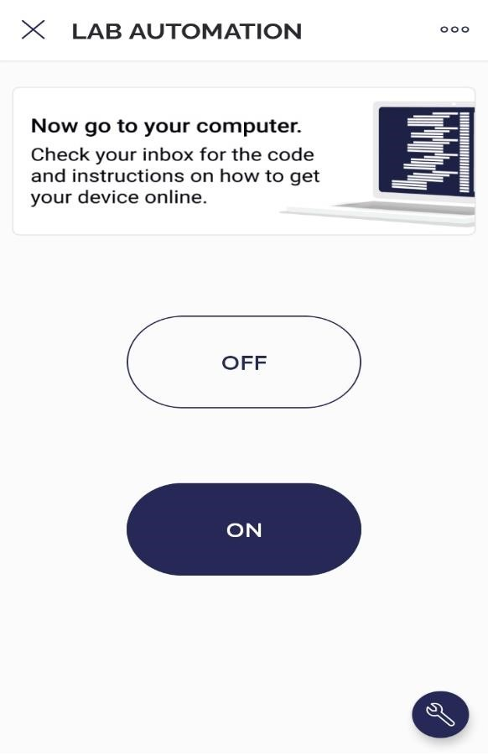

Fig.3.5 Blynk Interface

2. Arduino Software :
Arduino is an open-source electronics platform that consists of both hardware and software components. The software aspect of Arduino includes the Arduino Integrated Development Environment (IDE) and associated libraries. Here's some information about Arduino software.

The Arduino IDE is a cross-platform application that provides a user-friendly environment for writing, compiling, and uploading code to Arduino boards. It is available for Windows, macOS, and Linux operating systems.

CHAPTER-04
METHODOLOGY

4.1 METHODOLOGY

- Project Planning: Define the scope of the project, including the specific tasks to be automated in the lab, the expected outcomes, and the timeline. Identify the necessary hardware and software components, including the ESP8266 microcontroller, sensors, actuators, and communication protocols.
- Hardware Setup: Assemble and configure the necessary hardware components, including the ESP8266 microcontroller, sensors, and actuators. Connect them according to the project requirements and specifications, ensuring proper power supply and grounding.
- Software Development: Develop the software for the ESP8266 microcontroller using an appropriate programming language, such as Arduino IDE or MicroPython. Implement the logic and algorithms required for lab automation. including data acquisition from sensors, data processing, and control of actuators. Ensure efficient communication with other devices, such as a central server or a user interface
- Sensor Calibration and Testing: Calibrate the sensors to ensure accurate and reliable measurements. Perform extensive testing of the sensor readings and the overall system behavior in different scenarios and conditions to validate its functionality and performance. 5. Actuator Control: Implement the control logic for the actuators based on the sensor readings and user inputs. Test the actuator control to ensure that it operates as intended and is able to perform the required lab automation tasks effectively and safely
- Communication and Integration: Established communication between the ESP8266 microcontroller and other devices or systems, such as a central server or user interface. Ensure seamless integration of the lab automation system into the existing lab environment, including compatibility with other lab equipment and protocols
- User Interface Development: Develop a user interface, such as a web-based dashboard or a mobile app, to allow users to interact with the lab automation system. Implement features such as real-time monitoring, data visualization, and user controls to enable easy and intuitive operation of the system.
- System Integration and Testing: Integrate all the hardware and software components into a cohesive system. Conduct comprehensive testing of the integrated system to validate its overall functionality performance, and reliability. Make necessary adjustments and improvements as need.
- Documentation: Create documentation, including user manuals, technical specifications, and system diagrams, to provide comprehensive guidance on how to use and maintain the lab automation system
- Deployment and Training: Deploy the lab automation system in the lab environment and provide training to lab personnel on how to operate and maintain the system effectively and safe.

11.Maintenance and Support: Provide ongoing maintenance and support for the lab automation system, including periodic updates, troubleshooting, and technical assistance as needed to ensure its continued operation and performance. 12. Project Evaluation: Evaluate the success of the lab automation project based on the defined outcomes and goals. Gather feedback from users and stakeholders to identify areas for improvement and future enhancements.

4.2 METHODOLOGY DESCRIPTION

The lab automation project with ESP8266 is a cutting edge solution that combines the power of the ESP8266 microcontroller and automation technologies to streamline and optimize laboratory processes. The module is designed to automate various tasks in a laboratory environment, such as data collection, equipment control, and monitoring. creating an efficient and reliable workflow Features:
- ESP8266 Microcontroller: The module is built around the ESP8266 microcontroller, which is a versatile and powerful Wi-Fi enabled microcontroller capable of connecting to the internet and communicating with other devices. It offers! a high level of processing power, memory, and connectivity options, making it ideal for lab automation projects.
- Wi-Fi Connectivity: The ESP8266 module provides built-in Wi-Fi connectivity, allowing for seamless communication with other devices, such as smartphones, tablets, and computers. This enables remote monitoring and control of lab processes, eliminating the need for physical presence in the lab and increasing operational efficiency
3 Data Collection and Logging: The module is capable of collecting and logging various types of data from sensors, equipment, and other devices in the lab. This can be stored locally or transmitted to a cloud server for further analysis and processing The module supports a wide range of data formats, including text, numerical, and graphical data, making it highly flexible for different lab requirements
- Equipment Control: The ESP8266 module can be programmed to control various types of lab equipment, such as pumps. heaters, and sensor, based on predefined rules and conditions. This enables automated control of lab processes, reducing human error and improving repeatability and accuracy of experiments.
- User Interface: The module can be integrated with a user-friendly interface, such as a web-based dashboard or a mobile app, to provide easy and intuitive control and monitoring of lab processes. The interface can display real-time data, enable remote control of equipment, and provide notifications and alerts based on predefined events, enhancing the usability and accessibility of the system.
- Customization and Scalability: The module is highly customizable and scalable, allowing for easy integration with existing lab setups or the development of new lab automation systems. It can be programmed using popular programming languages, such as C/C++ or MicroPython, and supports a wide range of sensors, actuators, and communication protocols, making it adaptable to diverse lab requirements.

Benefits:
- Improved Efficiency: The lab automation module based on ESP8266 eliminates manual and repetitive tasks, reducing human error and increasing operational efficiency. It enables remote monitoring and control of lab processes, saving time and resources, and allowing researchers to focus on their core work
- Enhanced Data Collection and Analysis: The module enables automated data collection and logging from various lab devices, providing accurate and reliable data for analysis. It can also transmit data to cloud servers for further processing and analysis, enabling advanced data analytics and insights for informed decision-making insights for informed decision-making.
- Increased Experiment Reproducibility: The module ensures consistent and precise control of lab equipment, leading to improved experiment reproducibility. It eliminates variations caused by human intervention and provides a stable and controlled environment for experiments, enhancing the quality and reliability of research outcomes.
- Flexibility and Customization: The module is highly flexible and can be customized to suit different lab requirements. It can be integrated with existing lab setups or developed as a standalone system, and can be easily programmed and configured to meet specific automation needs.
- Cost-effective Solution: The lab automation module based on ESP8266 offers a cost- effective solution for automating laboratory processes. The ESP8266 microcontroller is affordable, and the module can be easily assembled and integrated with existing lab equipment, minimizing additional hardware costs.
Applications:
The lab automation module based on ESP8266 has wide-ranging.

CHAPTER-05
DESIGN OF THE PROJECT

DIAGRAM OF PROJECT
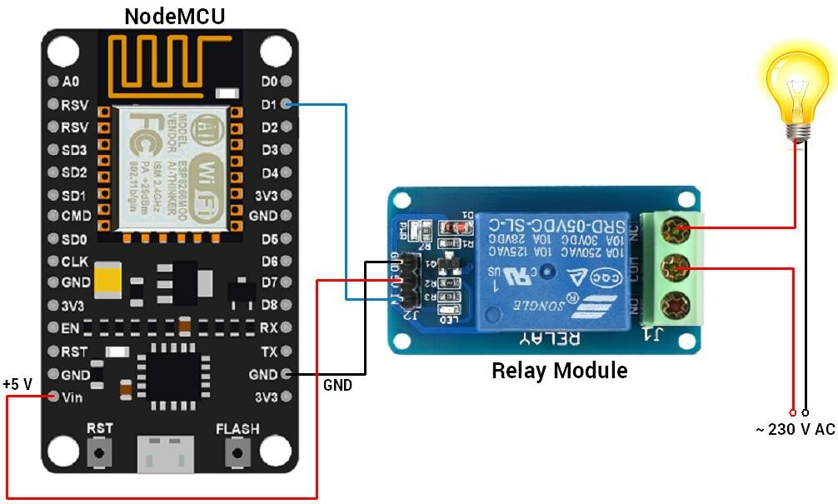

Fig.5.1 BLOCK DIAGRAM Fig.5.2 DATAFLOW DIAGRAM
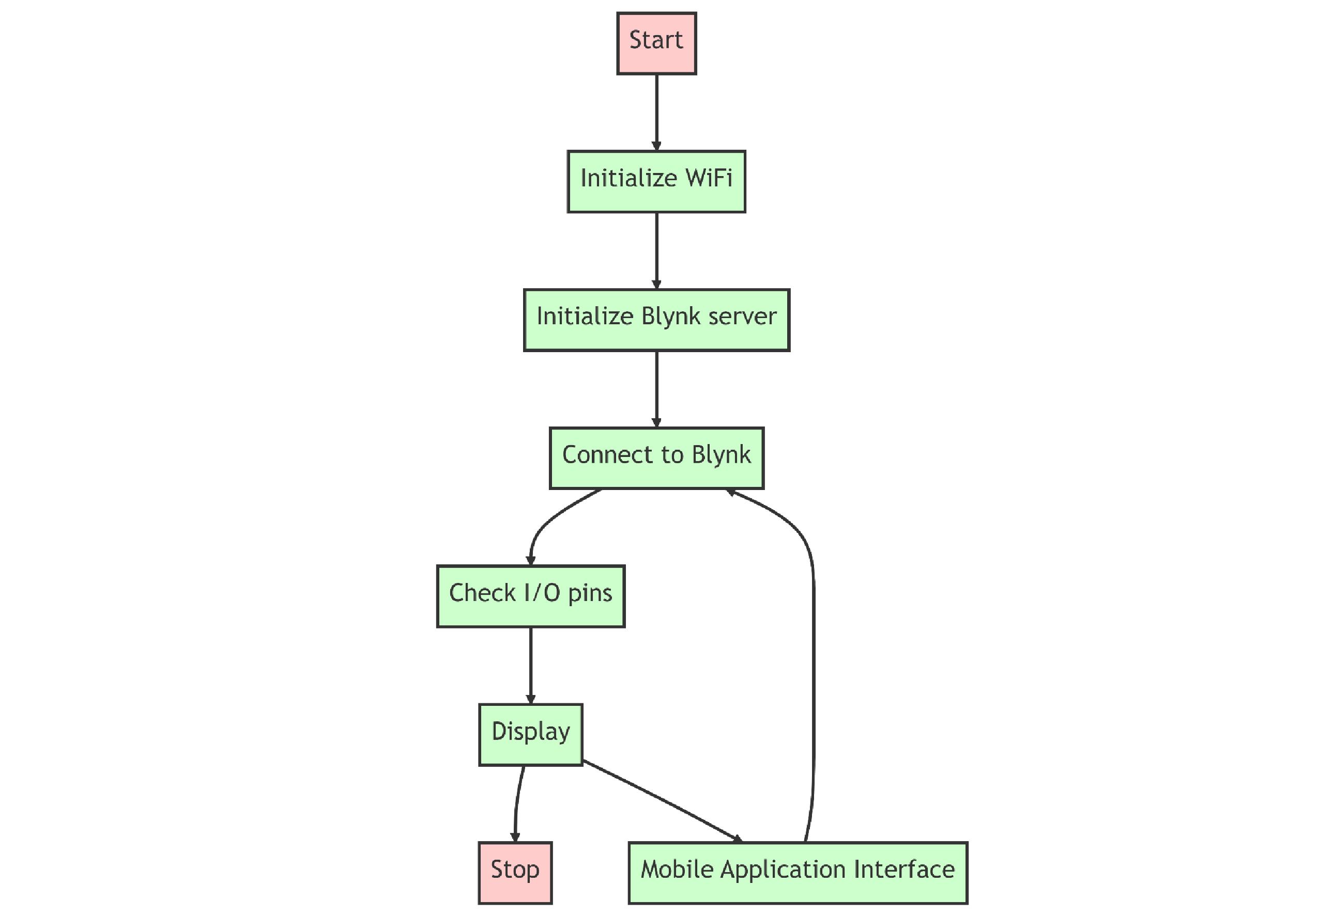
This flow chart shows the working of the project. The process starts be initializing the Wi-Fi, the network name and password are written in the code and uploaded to Node MCU. The android device is connected to Node MCU over Wi-Fi. The Blynk server is set up and connection is made, the devices is identified in the Blynk server using the generated authentication token. The command for controlling the load is given to the application, and this command, over Wi-Fi network is sent to the Node MCU.

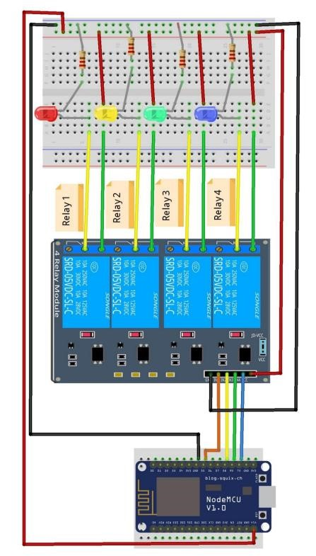

Fig.5.3 Circuit Diagram

CHAPTER-6
ADVANTAGES OF THIS PROJECT

ADVANTAGES

ESP8266 is a powerful and versatile microcontroller that can be used to create a wide range of Lab internation projects. Some advantages of using ESP8266 for lab automation include:
- Low Cost ESP8266 is a low-cost microcontroller compared in other options available in the market, makes it an excellent choice for DIY entlaniasts and malers who want to create a home automation project on a budget.
- WI-II Connectivity: ESP8266 comes with built-in Wi-Fi connectlylly, which means that you can connect it to your home network and control your home automation devices from anywhere in the World using your smartphone or tablet.
- Serall Size: ESP8266 is a small microcontroller, which means that it can be integrated into small devices without taking up much space. This makes it am ideal choice for bulding compact home automation devices.
- Easy to Program: ESP8266 key to program using the Ardoino, which popular programming emironment for microcontrollers. This means that you don't need to have advanced programming skills to create a home automation project using ESP8266.
- Wide Range of libraries : ESP8266 has a large and growing community of developers who have created many libraries and examples that make it emier to program and use in home autumnation projects.
- Open-Source The ESP8260 is an open-source project, which means that anyone can use and modify the hardware and software it their needs. This allows for greater customization and flexibility in creating home automation projects.
- MQTT Support: MQTT a lightweight messaging protocol that is ideal for home automation projects ESP8266 has built-in support for MOTT making it cary to connect your home automation devices a central server or hub

CHAPTER -7
APPLICATIONS, LIMITATIONS AND SCOPE OF

PROJECT

APPLICATIONS

- Sample Tracking and Management: The system can track the entire lifecycle of samples, from their arrival in the lab to storage, testing, and disposal. It allows lab personnel to efficiently manage sample information, monitor sample status, and track sample locations, reducing errors and improving traceability.
- Instrument Integration: Lab automation software can integrate with various laboratory instruments and equipment, enabling automated data collection and analysis. This integration eliminates manual data entry, reduces human error, and improves the overall efficiency of experiments and testing.
- Experiment Design and Execution: The software can assist in experiment design, protocol creation, and execution. It provides templates and tools to design experiments, define parameters, set up workflows, and automate repetitive tasks. This streamlines experimental processes, enhances reproducibility, and saves time for researchers.
- Data Management and Analysis: Lab automation systems can handle large volumes of data generated by experiments and testing. They provide centralized data storage, retrieval, and analysis capabilities. Scientists can perform data mining, statistical analysis, and generate reports with ease, leading to faster insights and decision-making.
- Workflow Automation: The software can automate complex laboratory workflows by defining and executing sequences of tasks. It enables the coordination of various processes, such as sample preparation, analysis, and reporting, reducing manual intervention and minimizing errors.
- Quality Control and Compliance: Lab automation systems can enforce quality control measures and regulatory compliance by standardizing processes, implementing validation protocols, and ensuring adherence to standard operating procedures (SOPs). This helps maintain consistent quality and compliance with industry standards and regulations.
- Resource and Inventory Management: The system can manage laboratory resources and inventory, including reagents, consumables, and equipment. It provides real-time visibility into stock levels, automates reordering processes, and helps prevent shortages or overstocking, thereby optimizing resource utilization.
- Collaboration and Documentation: Lab automation software facilitates collaboration among researchers and teams. It enables real-time sharing of data, protocols, and findings, as well as document version control. This promotes knowledge sharing, improves collaboration efficiency, and maintains a centralized repository of laboratory information.

LIMITATIONS

- Initial setup complexity: Implementing a software lab automation system requires careful planning and configuration. It can be a complex process, especially for larger organizations with diverse environments and a wide range of tools and technologies.
- Compatibility issues: Software lab automation systems need to be compatible with various tools, frameworks, and technologies used within the lab environment. Ensuring seamless integration and compatibility with different systems can be a challenge, particularly when dealing with legacy systems or proprietary tools.
- Maintenance and updates: Like any software solution, lab automation systems require ongoing maintenance and regular updates to stay functional and secure. This includes managing software patches, bug fixes, and system upgrades. Neglecting these maintenance tasks can lead to system instability or security vulnerabilities.
- Limited coverage of tools and technologies: Software lab automation systems may not support all the tools and technologies used in a specific lab environment. This limitation can hinder the ability to automate certain tasks or require manual intervention for certain toolsets or platforms.
- Lack of flexibility: While automation systems excel at repetitive tasks, they may struggle with handling complex scenarios or highly customized workflows. Some lab processes may be difficult to automate due to their unique nature or dependency on human judgment.
- Cost considerations: Implementing and maintaining a software lab automation system can involve significant costs. Organizations must consider the expenses associated with licensing, hardware infrastructure, training, and ongoing support. The initial investment may be a deterrent for smaller organizations with limited budgets.
- Security and compliance concerns: Automation systems can introduce security risks if not properly implemented and secured. Additionally, specific compliance requirements, such as data privacy regulations or industry standards, may add complexity to the automation process and necessitate additional controls and safeguards.
- Dependency on human intervention: While the goal of lab automation is to minimize manual intervention, there may still be instances where human intervention is required. Complex or unforeseen scenarios may require human expertise, troubleshooting, or decisionmaking.
- Scalability challenges: Scaling up a software lab automation system to accommodate growing needs and increased workload can pose challenges. Organizations may need to invest in additional hardware resources, optimize processes, and ensure that the automation system can handle the increased workload without performance degradation.
RESULT/ SNAPSHOTS

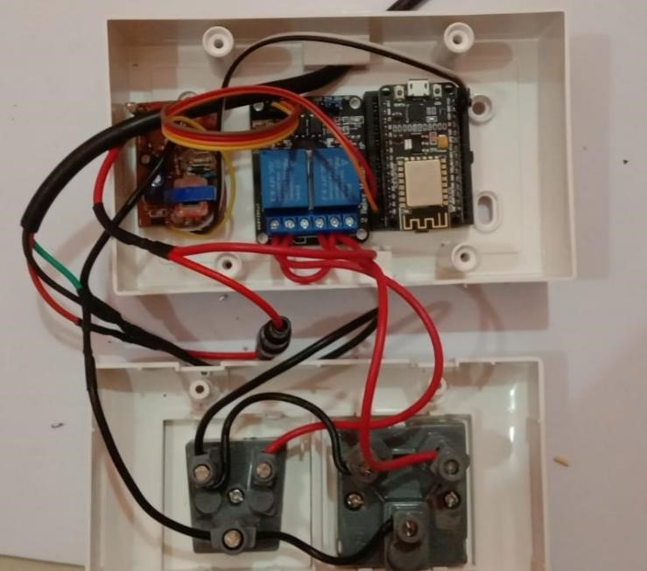

Fig.R.1 Result

1) Now let’s see how it’s visible the output :

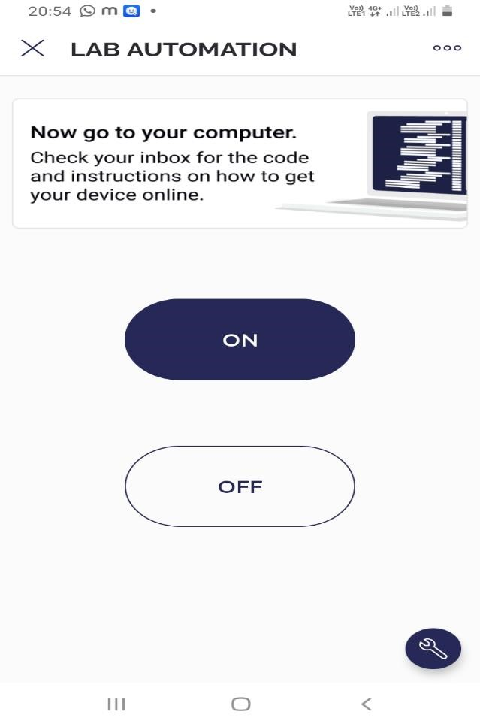

Fig.R.2 Interface of button

• When we click the first button and it turns ON . whenever we click the button from the blynk app then the device which is connect to that button respectively on as follow .
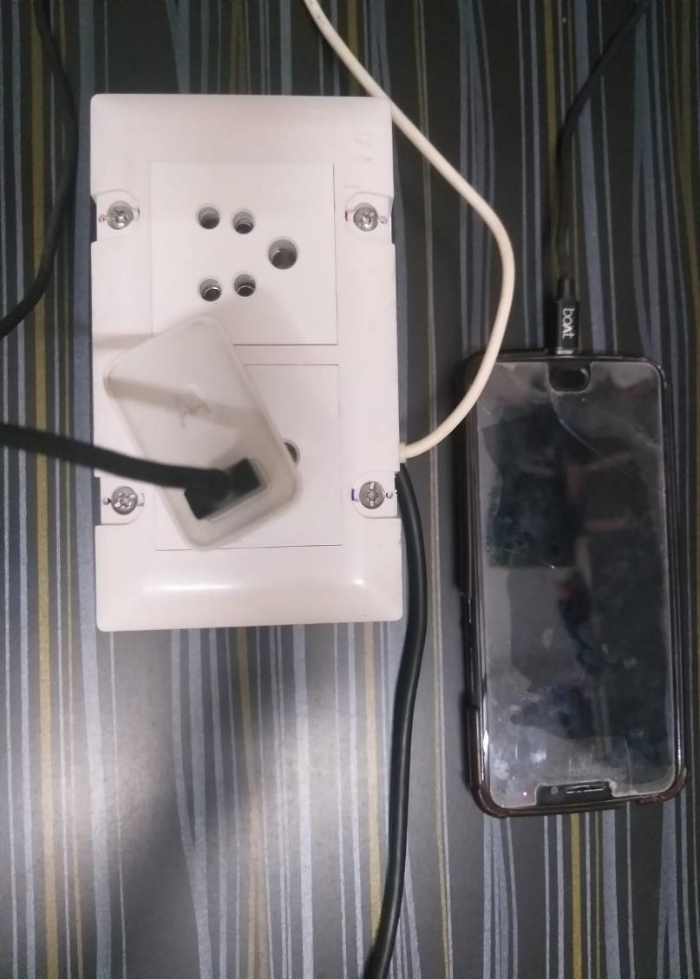

Fig. R.3 Output

The red Ligth indicate that whenever we click on First button from blynk app interface the Respective device is on .

2) Now let’s see how it’s turn off :

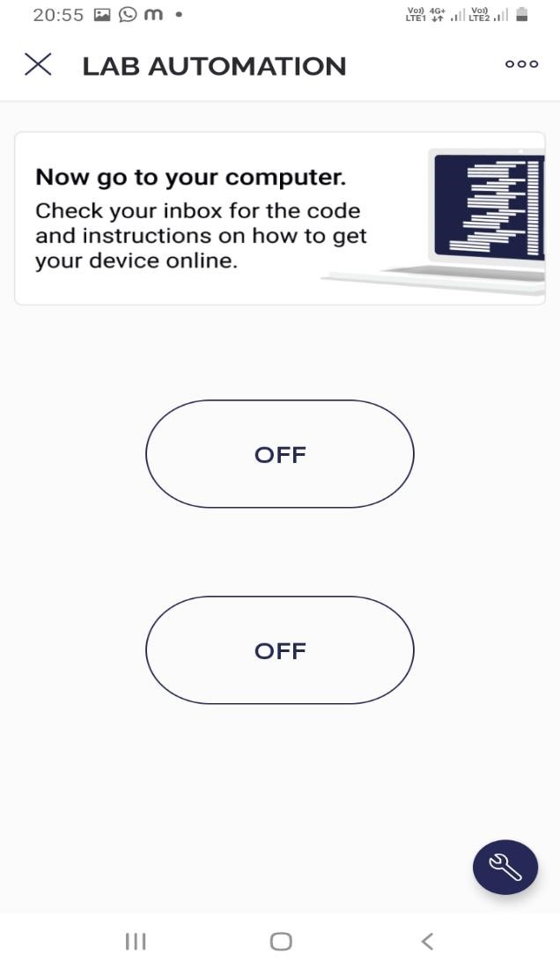

Fig.R.4 Off the button • When we click the first button it’s turn from ON to OFF . whenever we click the button from the blynk app then the device which is connect to that button respectively OFF as follow .
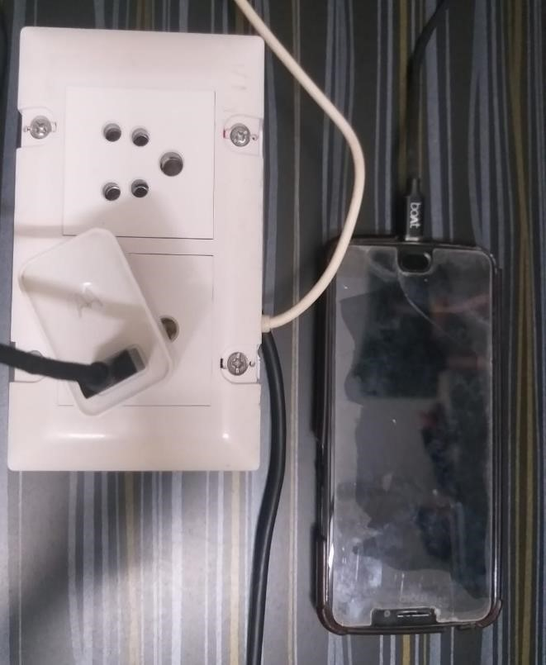

Fig R.5 OFF Output

In above diagram the red light is off .and we successfully see the output for both possibilities ON and OFF respectively.

CONCLUSION

In conclusion, loT-based Lab automation is an emerging technology that has revolutionized the way we live in our Labs. With the help of loT devices and systems, Lab owners can automate various aspects of their Lab, such as lighting temperature control, security. entertainment, and more. This technology offers numerous benefits, including increased convenience, energy efficiency, and cost savings Moreover, lot-based Lab automation has the potential to transform the way we interact with our homes and make our lives more comfortable and secure. However, it is crucial to ensure the security and privacy of the lot devices and systems to avoid any potential risks and vulnerabilities. As this technology continues to evolve, it is expected that more advanced and innovative solutions will emerge, providing even more exciting possibilities for the future of Lab automation.

FUTURE SCOPE

One of the major areas of focus for solar Inverter technology is to improve its efficiency Manufacturers are continuously working to reduce the power losses and increase the conversion efficiency of inverters, which can improve the overall performance of the solar energy system.
Energy storage integration with the increasing popularity of energy storage systems, solar inverters are being designed to integrate seamlessly with these systems. This will enable better control of the flow of electricity between the solar panels and the battery storage, maximizing the usage of solar energy and minimizing the reliance on the grid
As the power grid becomes more intelligent, solar inverters are being developed to be able to communicate with the grid and adapt to changes in demand and supply. This will enable better management of the electricity generated by solar panels and improve the stability of the grid.
Miniaturization Solar inverter manufacturers are working towards making smaller and lighter Inverters without compromising on performance. This will make installation and maintenance easier. especially in residential and commercial settings where space is limited.
Advanced monitoring and control To improve the performance and reliability of solar energy systems. manufacturers are developing advanced monitoring and control features in solar inverters. These features can enable better tracking of energy production and consumption, allowing for better optimization of the system.

REFERENCES

- https://en.wikipedia.org/wiki/Laboratory_automation

- What is IoT (Internet of Things) and How Does it Work? - Definition from TechTarget.com.

- Installing ESP8266 Board in the Arduino IDE: Step-by-Step Guide (lastminuteengineers.com)

- (PDF) IOT BASED LAB AUTOMATION USING - NODEMCU (researchgate.net)

